**D15B/37 Mikil Lalwani IP Lab 3**

**Aim -**

Explain the basics of CSS,

different ways of including CSS code in HTML, and different types of CSS selector.

**Theory-**

Cascading Style Sheets is a style sheet language used for describing the presentation of a document written in a markup language such as HTML or XML. CSS is a cornerstone technology of the World Wide Web, alongside HTML and JavaScript.

A pseudo-class is used to define a special state of an element.

For example, it can be used to:

1. Style an element when a user mouses over it
2. Style visited and unvisited links differently
3. Style an element when it gets focus

**Screenshots-**



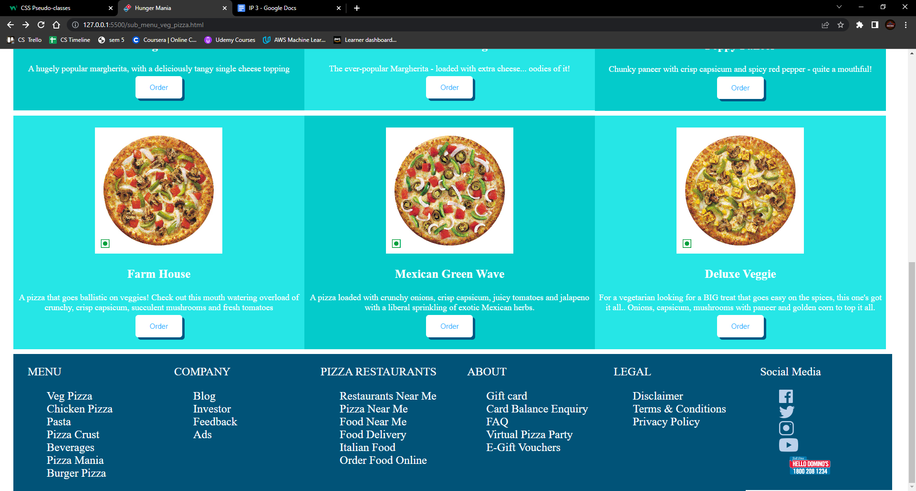

**Conclusion-**

We have successfully created a shopping website.